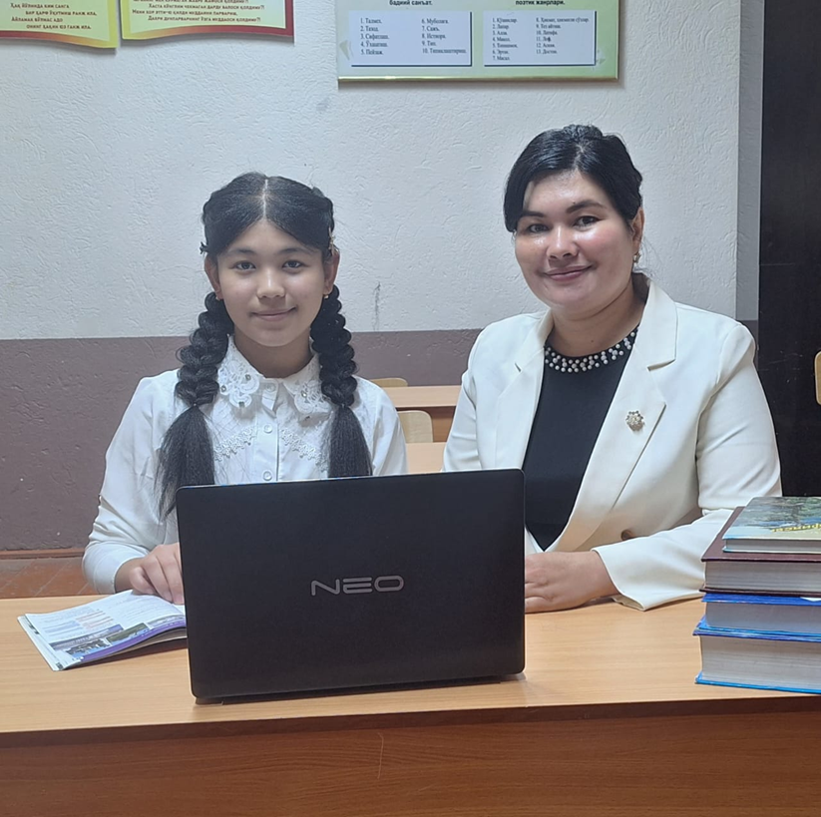Түркістан облысы Сайрам ауданының білім бөлімі

«№104 негізгі орта мектеп» кмм

9- сынып оқушысы

Каримкулова Дияна Хасановна

Жетекшісі ағылшын пәні мұғалімі

Нишанова Сарвиноз Исаметовна

My future profession is a teacher

In recent years more and more intelligent young graduates want to be a teacher. In my view, teaching is very satisfying job, and also it is my passion. All professions are good in the world I think. Perhaps our life would be completely different without doctors, lawyers and of course without teachers. Although I aware that teaching is a stressful and challenging job, teaching is highly-respected profession. I prefer to different professions, because all of them look very interesting, but my vocation is to be an English teacher. I love children and I feel better when I teach something to someone younger than me. Because I know how to manage with children.

Another thing I want to say is that my English teacher at school is Nishanova Sarvinaz. She is my favorite teacher at my educational department. When I at school, I look up my teacher. Because I could say that she is very grate and kind teacher. She taught me the secrets of the English language and told us many things that we did not know. Sarvinoz teacher works hard for every children to be good in the future and get on the right way in their life. Of course she was the first person who made me become an English teacher because when I saw Srvinoz teacher for the first time, I decided to myself «I will become a teacher like Sarvinoz teacher in the future ». She is the best person who found a way to my heart.

Actually in my opinion, for teachers It is important to love your subject, and interests to the children, like my teacher. These days the salary of a teacher in Kazakhstan is not so good. Unfortunately some professions without high education is paid better than profession of a teacher. But my choice is so, and I feel I am able to help our educational system. My purpose is learning many things from my future students. Hopefully ,the job has to make me happy and then every day I will wake up and go to work with smile.